

Application pack for:

Headteacher
Holy Cross Catholic Primary School, Plymouth

Plymouth CAST

Closing date for applications: Monday 20th April 2026 at 09:00 a.m.

Letter
FROM THE BOARD

Thank you for your interest in applying for the post of Headteacher of Holy Cross Catholic Primary School, Plymouth within Plymouth CAST Multi Academy Trust.

This is an exciting opportunity to join the skilled leadership team within our Multi Academy Trust of thirty-four Catholic schools and one nursery, formed in 2014. There are two secondary schools in the Trust, both are single sex schools based in Plymouth, and thirty-two primary schools. In geographical terms the Trust extends across seven local authority areas from Cornwall to Dorset. We have 1,150 staff and educate 6,700 children and young people. Our head office is located at St Boniface College in Plymouth.

Plymouth CAST has a strong focus on school improvement, underpinned by our Catholic values. Twenty-nine of our schools are currently Good or Outstanding and there is a strong positive momentum towards Good for all schools in the Trust.

We are passionately committed to the core aspiration of Catholic education which is the flourishing of the human person for the common good. To that end we have developed collaborative working through a cluster model to ensure that local expertise and best practice in our schools is shared and developed. Each of our schools are supported by a School Improvement Officer. The School Improvement Officers are managed by the Director of Education, who, with the Chief Finance Officer and Chief Operating Officer, make up the Senior Executive Management Team, led by the Chief Executive.

The Diocese of Plymouth has appointed a Diocesan Schools Commissioner, who works closely with the Chief Executive and the schools within the Trust, to ensure that the Bishop’s vision for education is actively promoted and embedded in all that we do.

If you would like an informal discussion about this role with our Director of Education, please contact our HR Team by email to careers@plymouthcast.org.uk

The deadline for applications is 09:00 a.m. on Monday 20th April 2026 and the interview process will take place shortly after this date. We will contact shortlisted candidates with further details of the selection process soon after the deadline. Our application form for this post can be accessed here.

Headteacher
Job Title | Headteacher
Remuneration | L14- L21 and appropriate pension scheme
Main Location | Holy Cross Catholic Primary School, Plymouth
Required for | September 2026
Relocation Expenses | Relocation expenses of up to £8,000 can be claimed for qualifying costs

Plymouth CAST, one of the largest Catholic Multi Academy Trusts in the country, is seeking to appoint an experienced headteacher.

Plymouth CAST is a Multi-Academy Trust comprising thirty-four schools plus a nursery situated within the Catholic Diocese of Plymouth with whom there is a close working relationship. The Trust is seeking to appoint a dynamic, strategic and practicing Catholic Headteacher at Holy Cross Catholic Primary School.

This is an exciting time to join a forward thinking and committed team, to both embed as well as shape working practices for the future. You will be joining a dedicated and supportive team and will have the opportunity to work with your School Improvement Officer and the Director of Education to help shape the way in which you will lead the schools to positively impact the education and development of the pupils.

The core purpose of the headteacher is to provide professional leadership and management for the school. This will promote a secure foundation from which to achieve high standards in all areas of the school’s work. To gain this success you must establish high quality education by effectively managing teaching and learning, using personalised learning to realise the potential of all pupils. You will be committed to establishing a positive and proactive culture that promotes excellence, focusing on collaboration and driving internal excellence, underpinned by our Gospel Values.

As headteacher you will provide vision, leadership and direction. You will ensure the school is managed and organised to meet its aims and targets. With the support from your line manager, you will be responsible for evaluating the performance of the school to identify the priorities for continuous improvement; raising standards; ensuring equality of opportunity for all; developing policies and practices; ensuring that resources are efficiently and effectively used to achieve aims and objectives and for the day-to-day management, organisation and administration of the school.

Within our Multi Academy Trust we operate a core business function which works to support headteachers and school communities in all areas of financial, personnel, estates and facilities, procurement and operational management.

You will need to develop excellent relationships with colleagues, local authorities and relevant agencies for children. Through such relationships you will play a key role in contributing to the development of the education system as a whole and collaborate with others to raise standards locally.

Our Trust governance model is designed to ensure our Board of Directors has a direct line of communication to schools, Local CAST Boards and school leaders.

You will be a practicing Roman Catholic in full communion with the Catholic Church. You should be able to evidence collaborative and inspirational leadership that creates a culture of high expectations and aspirations that raises standards and ensures that all children reach their full potential. You will have the interpersonal skills to guide and inspire your pupils and staff.

As headteacher you will need diplomacy, openness, approachability, and a personable style of leadership, as well as the ability to converse confidently with a wide range of internal and external stakeholders.

If you feel that you have the necessary skills and competencies, and the passion to make a difference to our children and young people, we would love to hear from you!

Essential requirements are:
- Practicing Catholic with a strong understanding of the structures and values of the Catholic Church
- Qualified to degree level relevant to the post and/or equivalent through professional experience.
- PGCE (or equivalent) – Qualified to Teach in the UK
- Recent, substantive and successful headship experience
- The ability to manage change through bringing innovative ideas to traditional approaches to teaching and learning
- Understanding and/or experience of managing finances and ensuring financial sustainability
- Excellent interpersonal and communication skills – an attentive listener and team builder.
- A wide knowledge of current and proposed education policy and the legal framework within which schools must operate, particularly in relation to safeguarding, when part of a Multi Academy Trust.

How to apply
If you would like an informal discussion about this role with our Director of Education, please contact our HR Team by email to careers@plymouthcast.org.uk
Our application form for this post can be accessed here.

Closing Date
09:00 a.m. on Monday 20th April 2026

Board
STRUCTURE

The Board and its committees are structured as below. The Board of Directors links to schools’ local governing boards through its link directive structure.

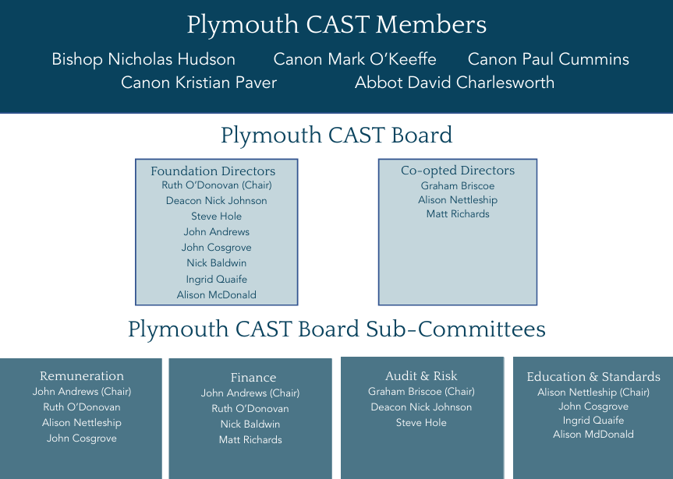

Organisational
CHART

CHIEF EXECUTIVE OFFICER
Zoe Batten

(EXECUTIVE ASSISTANT– Danielle Eves)

CHIEF FINANCE OFFICER  Karl Murphy Barnes |  |  | CHIEF OPERATING OFFICER  Rose Colpus-Fricker |  | DIRECTOR OF EDUCATION  Kevin Butlin
SBM TEAM | FINANCE TEAM |  | OPERATIONS TEAM |  | SCHOOL IMPROVEMENT TEAM
SBM  Claire Garden | FINANCE MANAGER  James Reed |  | HR MANAGER – Adelle Pope  SENIOR HR ADVISOR – Sarah Lugg  HR ADMINISTRATOR – Chloe Rawle |  | SCHOOL IMPROVEMENT OFFICER  (PRIMARY)  Charlotte Targett
SBM  Nichola Nelson | LEDGER CLERK  Rosalind Booth |  | TRUST GOVERNANCE OFFICER – Leah Paiano  GOVERNANCE ADMINISTRATOR – Melanie Harris |  | SCHOOL IMPROVEMENT OFFICER  (PRIMARY)  Jo Flower
SBM  Helen Newman | LEDGER CLERK  Clare Carter |  | ESTATES & FACILITIES MANAGER  Paul Stewart |  | SCHOOL IMPROVEMENT OFFICER  (PRIMARY)  Alyson Tyler
SBM  Janice Williams | FINANCE SUPPORT OFFICER  Zoe Dawe |  | PROCUREMENT & SERVICES MANAGER  Tina Parkes |  | SCHOOL IMPROVEMENT OFFICER  (PRIMARY)  Alan Frame
SBM  Pat Rushton |  |  | IT MANAGER  Russell Warren |  | SCHOOL IMPROVEMENT OFFICER  (PRIMARY & TRUST SEND LEAD)  Suzie Franklin
SBM  Belinda Burton |  |  | SECONDARY SCHOOLS BUSINESS MANAGER  Helen Laird |  | SCHOOL IMPROVEMENT OFFICER  (SECONDARY)  Stuart Gale
 |  |  | ADMINISTRATIVE ASSISTANT  Sharman Wood |  | EYFS ADVISOR  Lauren Stone
SAFEGUARDING
& STAFF DEVELOPMENT OFFICER
Leah Paiano

Plymouth CAST
MAP

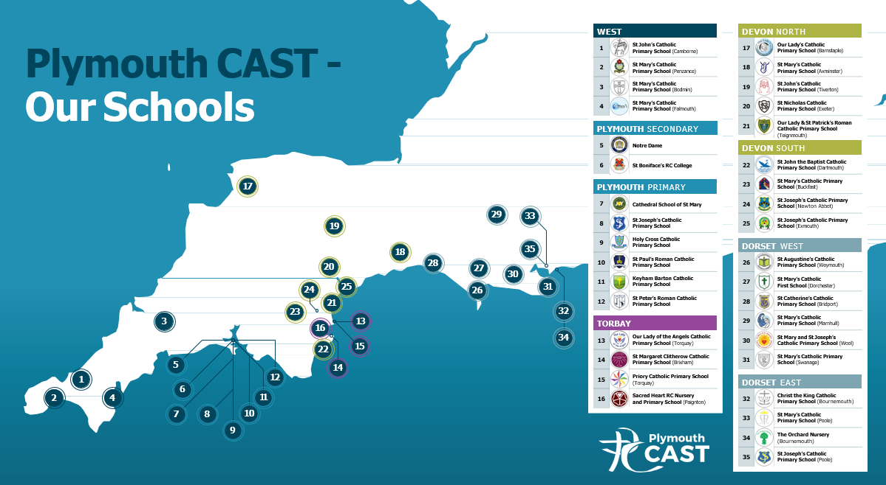

Job
DESCRIPTION

Job Title

Headteacher

Salary Range

L14 - L21 and appropriate pension scheme

Line Manager
School Improvement Officer

Base Location
Holy Cross Catholic Primary School, Plymouth.

Headteachers will work in a delegated school within the Trust. Normally, this will be the school through which the post holder has applied to work for the Trust. Due to the nature of the role, there will be no travel expenses paid between home and the place of work.

Occasionally, the Trust will need a headteacher to take up leadership of another school within the Trust. This will only happen for exceptional reasons. When this is the case, and the school is further from home than that applied for by the post holder, travel expenses will be paid for the extra distance the post holder needs to cover on each day.

Occasionally, headteachers will have meetings, training and activities at Plymouth CAST’s head office. Plymouth CAST is based at The Edmund Rice Building, Plymouth, PL5 3AG.

Line Management Responsibility

Over 15 employees, with some who have their own line management responsibilities.

Purpose of Role

The school has been designated by the Secretary of State as a school with a religious character. Its Instrument of Government states that it is part of the Catholic Church and is to be conducted as a Catholic school in accordance with Canon Law, the teachings of the Roman Catholic Church and the Trust Deed of the Diocese of Plymouth. At all times the school is to serve as a witness to the Catholic Faith in Our Lord Jesus Christ. The post therefore requires a practising Catholic who can show that he or she will ensure that the school is distinctively Catholic in all its aspects.

The Board of Directors and the diocese acknowledge the importance of the role of the Catholic headteacher and will actively offer continuing support, encouragement, affirmation and realistic challenge to the successful candidate.

The headteacher, working with the local governing body and others, is expected to draw on the person, life and teachings of Jesus Christ to create a shared vision and strategic plan, which inspires and motivates pupils, staff and all other members of the community. The vision should explore Gospel values, core educational values and moral purpose and be inclusive of stakeholders’ values and beliefs.

This appointment is made by Plymouth CAST and is subject to the current conditions of service for headteachers contained in the School Teachers' Pay and Conditions document and other current education and employment legislation.

Responsible to the School Improvement Officer, the headteacher will be responsible for strategic leadership, management and outcomes for the school and for building leadership capacity and maximising potential through the skills and resources.

This job description is based on the key areas identified in the National standards of excellence for headteachers published by the Department for Education (January 2015).

As Headteacher, you will be responsible to Plymouth CAST, and responsible for all staff and pupils in the school.

As the leader of the school, the headteacher is responsible for inspiring and embodying the Catholic ethos, securing the vision with all members of the school community and ensuring an environment for teaching that empowers staff and children to achieve their highest potential.

General duties and responsibilities
To carry out the duties of the head teacher as set out in the School Teachers’ Pay and Conditions document 2015 and related guidance by:
- leading by example, providing dynamic, consistent and motivational leadership, ensuring the successful delivery of the vision, ethos, aims and objectives of the Trust;
- holding and articulating clear values and moral purposes, focused on providing a world-class education for the pupils being served;
- demonstrating optimistic personal behaviour, positive relationships and attitudes towards their pupils and staff, and towards parents, governors, members of the local community and colleagues across the Trust;
- leading by example - with integrity, creativity, resilience, and clarity - drawing on their own scholarship, expertise and skills, and that of those around them;
- sustaining wide, current knowledge and understanding of education and school systems locally, nationally and globally, and pursue continuous professional development;
- working with political and financial astuteness, within a clear set of principles centred on the Trust’s vision, ably translating local and national policy into the school’s context;
- communicating compellingly the Trust’s vision and drive the strategic leadership, empowering all pupils and staff to excel.

Key Accountabilities
The following are job specific responsibilities.
A. LINE MANAGEMENT
- To provide leadership, management, support and challenge to any senior leaders across all aspects of their work.
- To agree challenging and meaningful targets for improved progress and attainment by supporting and informing senior leaders in self-evaluation and improvement planning.
- To be involved in the recruitment process of senior leaders at the school.
- To lead by example and develop leadership capacity at all levels, through a range of means including coaching and mentoring.
B. RESPONSIBILITY FOR STANDARDS
- To be responsible and accountable for the performance, standards achieved and quality of education in the school.
- To analyse pupil level data to challenge and support senior and middle leaders in the interpretation and use of data to raise standards.
- To ensure that evidence-based improvement plans inform actions and that the necessary actions needed to bring about improvement are implemented quickly and effectively to improve pupils’ development and welfare.
- To secure, sustain and quality assure effective, high-quality teaching and learning by ensuring sound strategies for monitoring and evaluating the quality of teaching and standards of pupil progress and achievement, setting targets for rapid improvement of all pupils.
- To quality assure and approve visits/trips/expeditions to be undertaken as part of pupils’ studies through the school curriculum.
- To produce, implement and monitor the school’s effectiveness, record in a precise self-evaluation and develop plans for improvement that tackle weaknesses.
- To lead staff to enable the achievement of the highest possible standards.
- To develop effective organisational and management structures and systems for, to ensure sustainability and effective succession planning.
- To develop partnerships with pupils, parents, the local community and other key stakeholders, including education and standards managers from CAST.
- To actively manage Ofsted visits, Section 48 inspections and other external visits.
C. CHAMPIONING PLYMOUTH CAST
- To embody the values of CAST in all that you do and to champion it in your interactions with staff, pupils, colleagues and all external stakeholders.
- To ensure the school as a family, and that you personally, drive sharing best practice and facilitation of school-to-school support.
- To hold and articulate clear values and moral purpose, focused on providing a world-class education for the pupils you serve.
- To demonstrate optimistic personal behaviour, positive relationships and attitudes towards your pupils and staff, and towards parents, governors and members of the local community.
- To lead by example - with integrity, creativity, resilience, and clarity - drawing on your own scholarship, expertise and skills, and that of those around them.
- To sustain wide, current knowledge and understanding of education and school systems locally, nationally and globally, and pursue continuous professional development.
- To work with political and financial astuteness, within a clear set of principles centred on the school’s vision, ably translating local and national policy into the school’s context.
- To communicate compellingly the school’s vision and drive the strategic leadership, empowering all pupils and staff to excel.
- To attend key events in the life of the Trust and in the locality the school resides.
D. LEADERSHIP DEVELOPMENT AND SUCCESSION PLANNING
- To be fully committed to leadership development and developing leadership qualities in all staff. As part of this, to act as a role model and ensure that you are continually developing your own character and competence as a leader and embodying this in all interactions.
- To be the driver of continual professional development, acting as an ambassador for the People agenda and marketing available opportunities for development within your school.
- To take a proactive approach to career development and succession planning within your school, encouraging and facilitating development opportunities and intentionally planning for the future.
E. STRATEGY
- To formulate the aims and objectives of the school in accordance with CAST policies.
- To produce and implement the School SEF and Improvement Plan, setting strategic targets and performance indicators.
- To ensure the school is an integral part of the locality and serves as a model of community transformation.
F. LEADERSHIP OF STAFF
- To ensure that the school is adequately and appropriately staffed, recruiting as necessary in accordance with CAST policies and procedures.
- To make certain that all staff receive appropriate, effective development and training to enable them to carry out their professional duties.
- To oversee an accurate assessment framework in order to embed consistently high standards and accurately judge the quality of teaching and learning.
- To ensure leadership of an annual performance management cycle is carried out within the school and that pay progression for teachers is appropriately managed.
G. LEADERSHIP OF PUPILS
- To ensure all pupils are in a safe, secure learning environment in accordance with CAST Safeguarding policies and statutory guidance; taking into account whole school strategies that promote awareness of and responses to risks to pupils’ welfare.
- To provide an effective system of pastoral care for all pupils.
- To ensure a rigorous assessment strategy for behaviour and safeguarding, as well as effective monitoring.
- To celebrate pupils’ success and enhance their learning by participating in a range of extra- curricular activities.
- To promote pupil voice and create ways for pupils to be involved in decision-making.
- To determine effective strategies to ensure high standards of behaviour and attendance.
- To ensure the school provides high quality spiritual, moral, social and cultural development for all pupils.
H. LIAISON WITH PARENTS/CARERS
- To prioritise engagement with parents and carers creating opportunities for parents to support and engage with the school, encouraging two-way communication and regularly sharing information.
- To hold regular parents’/carers’ evenings or review days and also ensure availability for discussion of their individual children’s progress or welfare on a needs basis.
I. CURRICULUM
- To determine, organise and implement a balanced, broad and personalised curriculum that meets individual pupil needs and has a positive impact on pupils’ outcomes and their personal development, behaviour and welfare. The curriculum should be effective, innovative and creative, using new technologies where appropriate.
- To regularly evaluate standards of teaching and learning and ensure high standards of professional practice are established and maintained.
- To ensure the school equips pupils positively for life in modern Britain and promotes fundamental British values.
J. THE MANAGEMENT OF RESOURCES
- To allocate, control and account for financial and material resources within remit.
- To have oversight of the maintenance and development of the premises and grounds to ensure maximum practical use and that Health and Safety requirements are met. Health and Safety is a key priority and you must ensure that everyone understands and upholds their responsibilities.
- To ensure all contracts for site management are negotiated to “best value” and that performance against contract is reviewed on a regular basis.
K. EXTERNAL LIAISON
- Create an outward-facing school that works with other schools and organisations in a climate of mutual challenge to champion best practice and secure excellent achievements for all pupils.
- Develop effective relationships with fellow professionals and colleagues in other public services to improve academic and social outcomes for all pupils.
- Challenge educational orthodoxies in the best interests of achieving excellence, harnessing the findings of well evidenced research to frame self-regulating and self-improving schools.
- Shape the current and future quality of teaching through high quality training and sustained professional development for all staff.
- Model entrepreneurial and innovative approaches to school improvement, leadership and governance, confident of the vital contribution of internal and external accountability.
- Inspire and influence others within and beyond the school to believe in the fundamental importance of education in young people’s lives and to promote the value of education.
- To develop collaborative links with other CAST schools, businesses and agencies to maximise the opportunities for staff, pupils and families.
- To maintain links with social services, the local police, churches, other faith groups and organisations involved in working with young people and the local community at large.
L. SAFEGUARDING CHILDREN
- Plymouth CAST is committed to safeguarding and promoting the welfare of children and young people. We expect all staff to share this commitment and to undergo appropriate checks, including enhanced DBS checks and safeguarding training, as expected by the latest statutory guidance from the Department for Education.
- Senior members of staff are required to undertake Safer Recruitment in Education training. The above responsibilities are subject to the general duties and responsibilities contained in the Statement of Conditions of Employment.
- The person undertaking this role is expected to work within the policies, ethos and aims of the academy and to carry out such other duties as may reasonably be assigned by the Director of Education and Standards. The post holder will be expected to have an agreed flexible working pattern to ensure that all relevant functions are fulfilled through direct dialogue with employees, contractors and community members.

Knowledge and Experience
Knowledge and Skills
- An ability to effectively prioritise and plan for self, others and the organisation.
- An ability to problem solve and think creatively when dealing with complex issues.
- An ability to develop and communicate a complex vision in simple and easily-understood terms to a variety of audiences.
- An ability to manage and empower others to maintain high standards of pupil discipline in order to ensure a positive climate for learning.
- An ability to lead school-wide improvement initiatives that have a demonstrable impact on pupil attainment.
- A wide knowledge of current and proposed education policy and the legal framework within which schools must operate, particularly in relation to safeguarding, when part of a Multi Academy Trust.
- A wide understanding of the links between education and community transformation.

Qualifications and Experience
- NPQH (desirable)
- Qualified to degree level
- PGCE (or equivalent) – Qualified to teach in the UK
- Evidence of recent, relevant professional development
- Leading and managing people individually and in teams to a high standard
- Managing change through bringing innovative ideas to traditional approaches to teaching and learning
- Managing and improving the curriculum offer resulting in demonstrable impact
- Understanding and/or experience of managing finances and ensuring financial sustainability
- Experience of managing risk across a school or organisation
- Experience of operating an organisation from a Health and Safety perspective
- Breadth of experience in school leadership, e.g. one or more from the following: pastoral and academic leadership experience; teaching in several contrasting schools or working in other sectors beyond education
- A proven track record of effective senior leadership
- Experience of working effectively with the local community a proven track record in improving outcomes
- Experience of supporting other leaders to achieve success through coaching or other relevant activities

Personal Qualities
- Practicing Catholic with a strong understanding of the structures and values of the Catholic Church
- Passionately committed to safeguarding and the welfare and wellbeing of children and young people
- Willingness to undergo appropriate checks, including enhanced DBS checks
- To work hard and remain fully committed, even when under pressure, always acting with consideration for yourself and others
- Forgiving and committed to healthy inclusive relationships (strong interpersonal & diplomatic skills)
- Emotionally resilient and therefore patient and persevering with challenging behaviours and attitudes
- To be hopeful, honest and always act with integrity, taking a rigorous approach to improving standards in order to ensure transformation of pupils lives and their wider communities
- Act with humility and as a team player by serving others both in the school and across the Trust
- Able to demonstrate and communicate the CAST ethos in your behaviours and actions
- Positive, passionate, enthusiastic, and able to help others be the same
- Able to keep a sense of proportion by acting with self-control
- Act with authenticity and integrity
- To have high aspirations and a commitment to excellence, and to role model this behaviour to others
- Self-disciplined and able to reflect and learn in order to develop wisdom and understanding.
- A willingness to promote and maintain the human face of the church ensuring that practices are consistent with the values in the Gospel.
- A sensitivity and empathy to working within a faith environment, and a strong understanding of the structures and values of the Catholic Church

Expected Outcomes

- Good working relationships are promoted with Trustees, Diocesan staff, School staff and Governors and Plymouth CAST staff.
- Responsible for own continuing self-development, undertaking training as appropriate or as directed as part of CPD.
- Being aware of and complying with all relevant policies and procedures relating to child protection, health safety and security, confidentiality and data protection and reporting all concerns to the appropriate person.
- Good working relationships are promoted with Trustees, Diocesan staff, School staff and Governors and Plymouth CAST staff.
- Plymouth CAST fully complies with its statutory obligations and records are maintained as required by law and made available when required by authorised persons.

This document outlines the duties for the time being to indicate the level of responsibility. It is not a comprehensive or exclusive list, and the duties may be varied from time to time which do not change the general character of the job, or the level of responsibility entailed.

The contents of this job description will be reviewed with the postholder on an annual basis in line with the Trust's appraisal policy. Any significant change in level of accountability that could result in a change to the grade will be discussed with the postholder before submitting for any re-evaluation.

Changes can be made to this job description under consultation to reflect the changing needs of the role at any time. This job description is currently subject to consultation.

Our
Gospel Values

Humility - seeing life as a gift

Compassion - empathy

Kindness - gentleness

Justice - working for a fairer world

Forgiveness - reconciliation

Integrity - do what you say

Peace - committed to peace-making, non-violence

Courage - standing up for truth

Our
Mission

“Our mission is to be a community of outstanding schools in which our students flourish in safe, happy and stimulating environments and leave us with the knowledge and skills, personal qualities and aspirations, to make the world a better place, inspired by the Gospel”.

A Vision of Excellence, approved by the Board, November 2018

