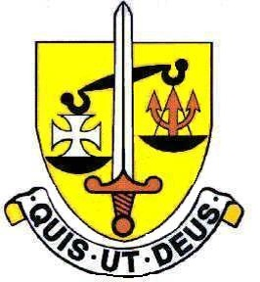

The Art Department

The Art Department at St. Michael’s is a very successful department and Art is a highly respected subject within the school curriculum. At GCSE uptake of the subject is good and Art & Design is a popular subject at A Level. Students are highly successful at gaining places on foundation courses and other Art related degree courses, going on to careers within Art & Design.

The pupils are highly motivated, talented and responsive; they rise to a challenge, finding lessons stimulating and richly rewarding. Staff should be passionate about their subject and need to stretch the most-able whilst supporting the weaker student.

There are currently 3 Art teachers and one technician working in the Art department. We very much work as a team, discussing and developing ideas and approaches to teaching. There are well established schemes of work in place in all key stages which have been written collaboratively. There is much emphasis on the development of drawing leading into other techniques. First hand study is very important and visits to galleries and museums are used in all key stages to launch projects. We make much use of the resources available locally in London plus we have taken students to key cultural cities abroad such as New York. Reference to contemporary artists is made particularly at A Level.

The Art department is in the modern Senior Building – there are 2 art rooms which are both used for general Art & Design, including drawing, painting and printmaking. In addition, Art Room 1 is equipped for the use of clay and Art room 2 has facilities for silkscreen printing, batik and machine embroidery.

Cross-curricular work is also undertaken through links with the RE, Drama and Music departments with the designing and making of props for school productions and celebrations.

The department is forward thinking and progressive; we invite visiting artists to work with the students and we enter student work for competitions. We have developed strong links with the Royal Academy of Art where the Head of Art is part of the teachers’ panel and she is also an A Level moderator.

There is an open door policy at lunchtimes and Art Club is run weekly after school to support GCSE and A- Level students.

Should you wish to join our Art Department please be prepared to bring a portfolio of work to illustrate your experience within teaching at all key stages plus examples of your own work, including drawing.

September 2026

