
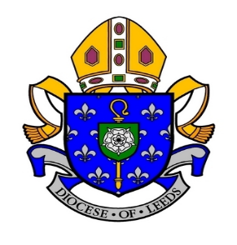
St Edward’s Catholic Primary School
Westwood Way, Boston Spa, Wetherby, LS23 6DX
Telephone: 01937 843946

‘Through God’s Grace We Grow and Learn’

KS2 Class Teacher & TLR 2A

(Non-Catholic applicants welcome)
MPS-UPS & TLR 2A

NOR: 193

The Governors are seeking to appoint an excellent full-time KS2 Class Teacher & TLR 2A to join our team from 1st September 2025. We are looking for a highly motivated, enthusiastic, and dedicated individual to work in partnership with our Headteacher to build on the strengths of our outstanding school.

The Governors of this outstanding school are seeking to appoint a motivated and enthusiastic KS2 class teacher with TLR 2A, who:

- Is dedicated and enthusiastic about teaching.
- Is highly motivated and able to work in a team.
- Is a good/outstanding classroom practitioner.
- Will lead a whole school area (SEND or Assessment)

We can offer you:
- A friendly team committed to providing an excellent education for every child.
- Well behaved children who love learning and want to achieve.
- A high level of community involvement.
- Continued professional development to further your career.

You must be able to promote the Catholic ethos of the school and be prepared to join in the wider life of the school community. Applicants do not have to be Catholic.

For an application pack please contact:
stedwardsadmin@st-edwards.leeds.sch.uk

Deadline for applications: Friday 2nd May at 4pm
Interview date: Thursday 8th May

This school is committed to safeguarding and promoting the welfare of children and young people and expects all staff and volunteers to share this commitment. An Enhanced Criminal Records Disclosure and references will be sought from the successful candidate prior to appointment.

